2021Vision - Fellowship
Dr. David Bray - January 24, 2021
Mission Statement of El Camino Grace Church
Our Goal is to reach our Community, and the World for the Lord Jesus Christ, and to teach God’s People a Scriptural World View, so that we can Live and Serve The Lord in this Generation.
Scripture Text: Acts 2:42-47 “They devoted themselves to the apostles’ teaching and to fellowship, to the breaking of bread and to prayer. 43 Everyone was filled with awe at the many wonders and signs performed by the apostles. 44 All the believers were together and had everything in common. 45 They sold property and possessions to give to anyone who had need. 46 Every day they continued to meet together in the temple courts. They broke bread in their homes and ate together with glad and sincere hearts, 47 praising God and enjoying the favor of all the people. And the Lord added to their number daily those who were being saved.” Having a 2021 Vision means our focus will be on:
1
Reaching the World around us- Acts 2:36-38 “Therefore let all the house of Israel know assuredly that God has made this Jesus, whom you crucified, both Lord and Christ.”…38 Then Peter said to them, ‘Repent, and let every one of you be baptized in the name of Jesus Christ for the remission of sins; and you shall receive the gift of the Holy Spirit.’”(vs. 36-38a)
2
Teaching God’s People a Scriptural World View- “They devoted themselves to the apostles’ teaching and to fellowship, to the breaking of bread and to prayer.” (vs. 42)
3
Growing Strong in with Love-“…and to fellowship, to the breaking of bread…”(vs. 42c) … “They broke bread in their homes and ate together with glad and sincere hearts,” (vs. 46b) Through Fellowship they grew strong by:
  - Spending Together- “Every day they continued to meet together in the temple courts.” (vs. 46a) The early church:
    - together- “When the Day of Pentecost had fully come, they were all with one accord in one place.” (vs. 2:1)
    - each-other- “Let no unwholesome word come out of your mouth, but if there is any good word for edification according to the need of the moment, say that, so that it will give grace to those who hear. 30 Do not grieve the Holy Spirit of God, by whom you were sealed for the day of redemption. 31 All bitterness, wrath, anger, clamor, and slander must be removed from you, along with all malice. 32 Be kind to one another, compassionate, forgiving each other, just as God in Christ also has forgiven you.” (Eph. 4:29-32)
    - each other through the Fruit of the Holy Spirit- “…they broke bread in their homes and ate together with glad and sincere hearts…” (vs. 46b) &“But the fruit of the Spirit is love, joy, peace, longsuffering, kindness, goodness, faithfulness, 23 gentleness, self-control. Against such there is no law.” (Gal. 5:22-23)
  - Studying the Together- “They devoted themselves to the apostles’ teaching and to fellowship…” (vs. 42a)
  - Breaking Together- “…and to fellowship, to the breaking of bread and to prayer.” (vs. 42b)

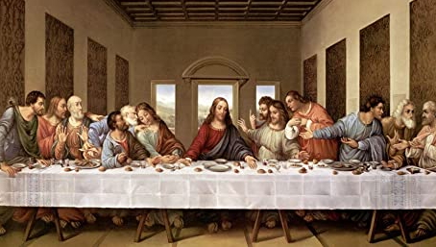




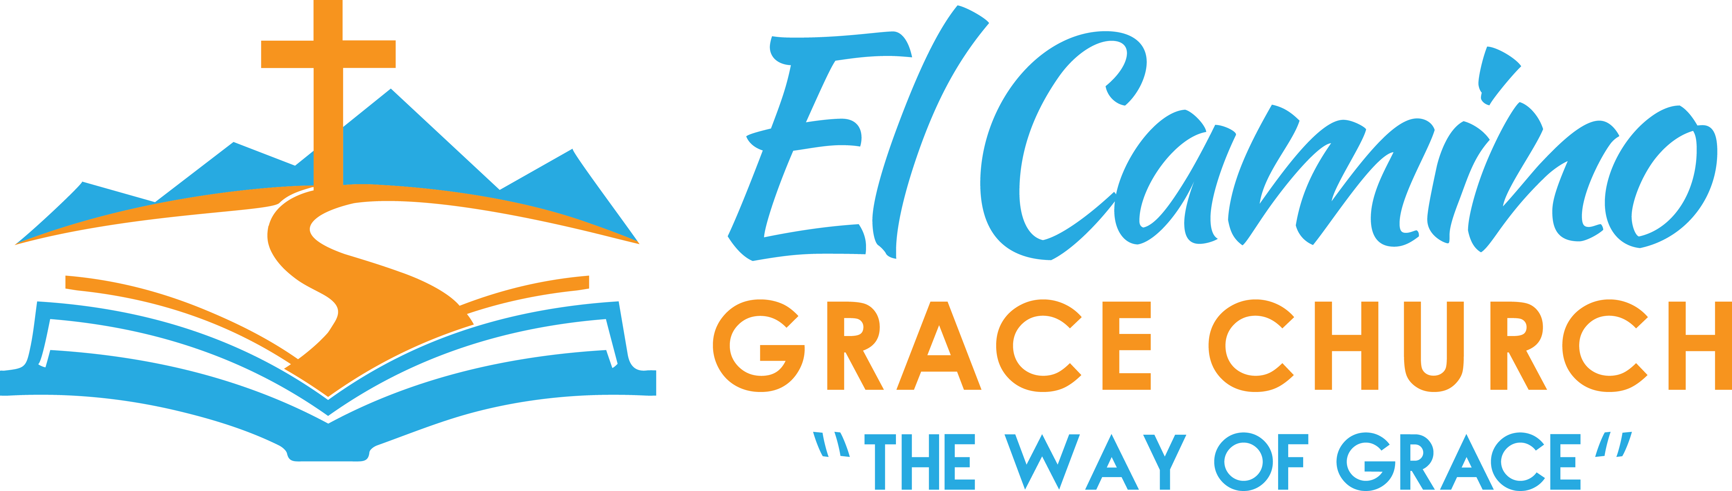
Want to Give through
credit/debit card?

Call Jan Patchett at 619-890-9914
CONTACT US:
1150 Broadway, Suite 234
El Cajon, CA 92021
If you have questions:
Call Raylene at 619-733-0748
Email: raylene7777@icloud.com
www.elcaminograce.org
Lord’s Supper
Sunday, February 7
Church Services:
9:00 AM and 10:45 AM
2021 VISION
Part 3: Fellowship
www.elcaminograce.org

