2021Vision - Part 2
Dr. David Bray - January 17, 2021
Mission Statement of El Camino Grace Church
Our Goal is to reach our Community, and the World for the Lord Jesus Christ, and to teach God’s People a Scriptural World View, so that we can Live and Serve The Lord in this Generation.
Scripture Text: Acts 2:42-47 “They devoted themselves to the apostles’ teaching and to fellowship, to the breaking of bread and to prayer. 43 Everyone was filled with awe at the many wonders and signs performed by the apostles. 44 All the believers were together and had everything in common. 45 They sold property and possessions to give to anyone who had need. 46 Every day they continued to meet together in the temple courts. They broke bread in their homes and ate together with glad and sincere hearts, 47 praising God and enjoying the favor of all the people. And the Lord added to their number daily those who were being saved.” Having a 2021 Vision means our focus will be on Teaching God’s People a Scriptural World View. Transformation of new believers happened because they were committed to:
Romans 12:1-2 “I beseech you therefore, brethren, by the mercies of God, that you present your bodies a living sacrifice, holy, acceptable to God, which is your reasonable service. 2 And do not be conformed to this world, but be transformed by the renewing of your mind, that you may prove what is that good and acceptable and perfect will of God.” (NKJV)
1
Pursuing the___________ - “They devoted themselves…” (vs. 42a)
2
Learning the______________ - “…to the apostles’ teaching…” (vs. 42b) …“Every day they continued to meet together in the temple courts.” (vs. 46a) The Apostles taught them to:
  - _________ Jesus as the Messiah of the Scriptures- “Therefore let all the house of Israel know assuredly that God has made this Jesus, whom you crucified, both Lord and Christ.” (vs.36) (Acts 2:22-36)
  - Become ____________ of Jesus- “And they continued steadfastly in the apostles’ doctrine and fellowship, in the breaking of bread, and in prayers.” (vs. 42)
  - Pursue ___________ in their lives- “And they continued steadfastly in the apostles’ doctrine and fellowship…” (vs. 42)
  - Walk by _________ - “Now all who believed were together, and had all things in common, 45 and sold their possessions and goods, and divided them among all, as anyone had need.” (vs. 44-45)
  - Become ___________ of men- “Praising God and having favor with all the people. And the Lord added to the church daily those who were being saved.” (vs. 47)
3
Praying with _____________ -“…and to prayer.” (vs. 42d) … “Everyone was filled with awe at the many wonders and signs performed by the apostles.” (vs.43)


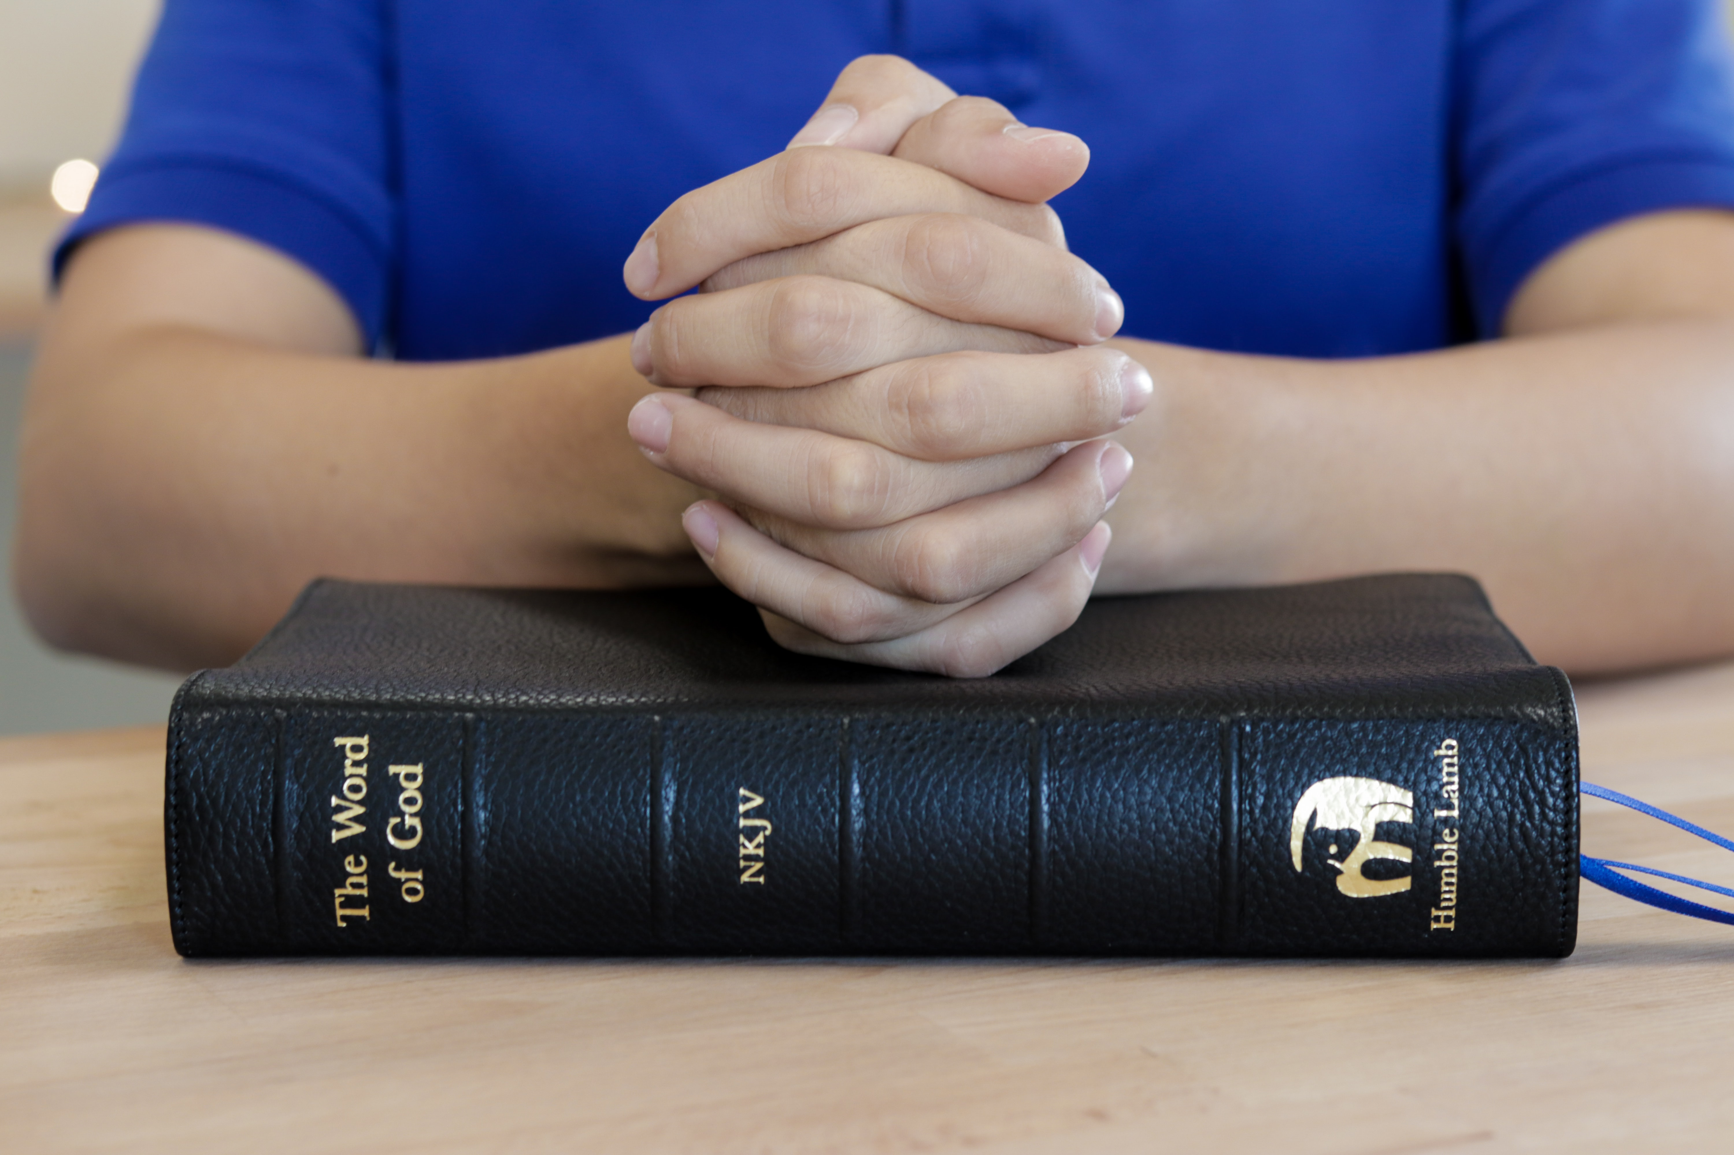




Want to Give through
credit/debit card?

Call Jan Patchett at 619-890-9914
CONTACT US:
1150 Broadway, Suite 234
El Cajon, CA 92021
If you have questions:
Call Raylene at 619-733-0748
Email: raylene7777@icloud.com
www.elcaminograce.org
Pray For God’s Grace Upon Our Nation And For The Turmoil To Turn To Peace
2021 VISION
www.elcaminograce.org
Part 2: Teaching A Scriptural
World View

